Web Application Security Audit Report
of
Department of FCSCA.
Website: http://164.100.117.150/elekhaHome.aspx
Submitted By
Secnic Consultancy

Report Release Date | 21.08.2025
Type of Audit | Application Security Aduit
Type of Audit Report | Level 1 Report
Period | Aug 21, 2025 to Aug 29, 2025

© 2025 Department of FCSCA.
All rights reserved. All information contained in this document is confidential and proprietary to Department of FCSCA. No part of this document may be photocopied, electronically transferred, modified, or reproduced in any manner without the prior written consent of Department of FCSCA.
All brands or product names are trademarks or registered trademarks of their respective companies or organisations.

Document Control

Document Preparations
Document Title | Application Security Audit Report
Document ID | SCS/WAC/202503
Document Version | 1.0
Prepared By
Reviewed By
Approved By
Released By
Released Date | 21 Aug 2025

Document Change History

Version | Date | Remarks
1.0 | Aug 21, 2025 | Level 1 report

Document Distribution List

Name | Organization | Designation | Email Id
Atul Suri | Manager (Quality & Audit) | Department of FCSCA

Table of Contents

1. EXECUTIVE SUMMARY 3
1.1 Introduction 3
1.2 Scope 3
1.3 Summary of Findings 4
1.4 Overall Assessment 4
1.5 Key Vulnerabilities Discovered 5
2. OVERALL SUMMARY OF FINDINGS 6
3. BENCHMARKING WITH OWASP 6
4. KEY FINDINGS AND ACTION ITEMS 8
5. General Guidelines 16

EXECUTIVE SUMMARY

Introduction
This report presents the results of the penetration testing for the Department of FCSCA. Website (http://164.100.117.150/elekhaHome.aspx) The objective of the test was to find out vulnerabilities that can be seen and compromised by malicious users from the Internet. The application was found to be vulnerable to security risks including Security Misconfiguration, & Denial of Service issues etc... The following sections provide details of the scope of the penetration test, the IPs on which detailed penetration testing was conducted, and the detailed findings from the penetration testing exercise.

Our opinion provided in this report is valid for the period during which the penetration testing was carried out and is based on the information and the website contents provided for audit. Projection of any conclusions based on our findings for future periods and application versions is subject to the risk that the validity of such conclusions may be altered because of changes made to the network or application or system or the failure to make the changes to the network, application, system when required.

Disclaimers and Restrictions
- Organization’s management is responsible for its assertions. Our responsibility is to express an opinion on management’s assertion based on our audit.
- The audit was conducted in accordance with the Information Systems Auditing Standards issued by the Standards Board of Information Systems Audit and Control Association. Further, the objective of the audit was to obtain reasonable assurance that the assertion is not materially misstated. Our audit included
  - Obtaining an understanding of the objectives;
  - selectively testing these objectives;
  - testing and evaluating; and
  - performing such other procedures as we considered necessary under the circumstances. We believe that our audit provides a reasonable basis for our opinion.
- Because of inherent limitations in controls, errors or fraud may occur and may not be detected. Furthermore, the projection of any conclusions, based on our findings, to future periods are subject to the risk that changes made to the system or controls, changes in processing requirements, changes required because of the passage of time, or degree of compliance with the policies or procedures may alter the validity of such conclusions.
- This report is strictly to be used for the intend purpose of compiling the controls being followed for the purposes of analysis and improvement.
- It is firmly recommended to test out all our technical recommendations to the system internals such as services or registry in a test environment and the impact on the reliability and integrity of the system be evaluated before rolling out the changes to the production environment.
- This report does not include any representation on the financial, marketing, human resources or any other health of the Organization or on the future viability of the Organization or minimizing or exposure of all risks associated with computerized environment, due to its inherent limitations.

Details of the Auditing Team
Sr. No. | Name | Designation | Email Id | Professional Qualifications/ Certifications | Whether the resource has been shortlisted in the snapshot information published on Cert-In’s website (Yes/No)
1 |  |  |  | CISA, ISO 27001 LA | Yes
2 |  |  |  | ISO LA | Yes
3 |  |  |  | CEH | Yes

Audit Activities and Timelines

Audit Phases | Timelines
Receipt of URL/Application Auditee for Audit | Aug 21, 2025
Execution of Assignment
Report Preparation
Report Submission to Auditee | Aug 29, 2025

Audit Methodology and Criteria / Standard referred for audit
During the course of this review, we assessed the activities as stated above for compliance with OWASP & other known vulnerabilities and best practices, as applicable. We conducted the assignment using automated tools and conducting manual testing, as applicable.

Tools/Software Used

Sr. No. | Name of Tool/Software Used | Version of the tool/Software used | Open Source/Licensed
1. | Burp Suite Professional | 2024.5 | Licensed
2. | Invicti Standard | 25.5.1 | Licensed
3. | Kali Tools |  | Open Source
4. | Manual scripts

Scope
The following table details an overview on the scope of the penetration test.

Details
Application Name | IAOS
Testing IP/URL | http://164.100.117.150/elekhaHome.aspx
Mode of Test | Grey Box Testing

Summary of Findings
Penetration testing on the Website (http://164.100.117.150/elekhaHome.aspx ) was performed for a period of 3 days. As a result of the penetration test following risks were identified:
No of Findings | Critical | High | Medium | Low | Informational
15 | 0 | 3 | 8 | 5 | 0

The table below gives an overall result of the findings from the penetration testing exercise. The “Key Findings and Action Items” section gives the details of the vulnerabilities and provides the recommendations to mitigate them.

Overall Assessment
We have identified 16 vulnerabilities during the penetration testing of the (http://164.100.117.150/elekhaHome.aspx). The team concluded the risks based on the results of the various tests carried out during the penetration testing process. The following table lists down the key vulnerabilities discovered.

Key Vulnerabilities Discovered
Sr. No. | VULNERABILITY | RISK LEVEL | REMARKS &  ACTION ITEMS
1. | Outdated JQuery version | High | Upgrade jQuery to the latest stable and secure version (3.x series).  Avoid version disclosure
2. | Sensitive Backup /Certificate Files Accessible | High | Restrict Access: Ensure that sensitive files (.bak, .old, .zip, .tar, .pem, .crt, .key)  Apply proper file permission settins and web server restrictions.  Secure Configuration: Configure the web serverto deny access to backup and certificate directories
3 | Broken CAPTCHA Validation | High | The application implements a CAPTCHA field on the login page to prevent automated or brute-force attacks. However, testing revealed that CAPTCHA validation is not properly enforced on the server side.
4. | Cross Domain Misconfiguration | Medium | Ensure that sensitive data is not available in an unauthenticated manner (using IP address white-listing, for instance).  Configure the "Access-Control-Allow-Origin" HTTP header to a more restrictive set of domains, or remove all CORS headers entirely, to allow the web browser to enforce the Same Origin Policy (SOP) in a more restrictive manner.
5. | Content Security Policy header missing | Medium | Content Security Policy (CSP) is an added layer of security that helps to detect and mitigate certain types of attacks, including Cross Site Scripting (XSS) and data injection attacks.
6 | Rate Limiting Missing on Login Endpoint | Medium | The login endpoint does not enforce rate limiting or account lockout mechanisms, allowing unlimited authentication attempts without restriction.
7 | Cross-Domain JavaScript Source | Medium | The application includes JavaScript files from external (cross-domain) sources. If those external sources are compromised or controlled by an attacker, malicious JavaScript can be executed in the context of your website.
8 | Vulnerable JavaScript Library Detected | Medium | The application is using an outdated or vulnerable JavaScript library (such as jQuery, Angular, Bootstrap, etc.) that contains known security flaws. Attackers can exploit these vulnerabilities to perform attacks like XSS, code injection, or bypassing security controls.
9 | Missing Anti-CSRF Token in Forms | Medium | The application’s forms do not implement Anti-CSRF (Cross-Site Request Forgery) tokens. Without these tokens, attackers can trick authenticated users into unintentionally performing malicious actions (such as changing passwords, transferring funds, or modifying account details).
10 | Server Security Headers Missing | Medium | The application’s HTTP responses are missing important security headers (such as Content-Security-Policy, X-Content-Type-Options, Strict-Transport-Security, X-Frame-Options). These headers help protect against attacks like clickjacking, MIME sniffing, and code injection.
11 | X-Content-Type-Options Header Missing | Medium | Attackers can exploit MIME-sniffing behavior to execute malicious scripts.  May result in Cross-Site Scripting (XSS) or content injection.  Reduces the effectiveness of other security mechanisms
12 | Information Disclosure via X-Powered-By (ASP.NET) | Low | The application discloses its underlying technology stack through the X-Powered-By HTTP response header (e.g., ASP.NET). Revealing framework and version details gives attackers valuable information that can be used to identify known vulnerabilities or tailor attacks.
13 | User-Agent Fuzzer Info | Low | Reveals inconsistencies in how the application processes HTTP headers.  May allow attackers to perform denial of service (DoS), logic bypass, or even exploit hidden bugs.  Can expose information about server-side filtering, logging, or monitoring mechanisms.
14 | Timestamp Disclosure in Response Headers | Low | The application’s HTTP response headers include a timestamp value (e.g., Date, Last-Modified, or custom headers). Disclosing such information may assist attackers in determining the server’s internal clock, uptime, or file modification times, which can be useful for reconnaissance and targeted attacks.
15 | Session Management Response identified | Low | The application’s HTTP responses reveal session management details (such as Set-Cookie, ASP.NET_SessionId, JSESSIONID, or other session identifiers).
16 | X-Aspnet version response Header | Low | The application discloses the ASP.NET version in the X-AspNet-Version HTTP response header.

OVERALL SUMMARY OF FINDINGS
Below Chart gives the overall summary of number of Vulnerabilities discovered with the Risk rating. Total of 16 vulnerabilities High-3 medium-8 Low-5 Informational level Vulnerabilities were reported.

BENCHMARKING WITH OWASP
The below chart depicts the number of discovered vulnerabilities mapped to OWASP Testing Category.

OWASP has rated the Top Ten Vulnerabilities found in web applications worldwide. OWASP Top Ten Vulnerabilities details can be found at below link.

https://owasp.org/Top10/

The table shows the application vulnerability mapped with respect to the OWASP Top 10 - 2021 list.

Sl. No | Vulnerabilities | Status
1 | Injection Flaws | protected
2 | Broken Authentication | Unprotected
3 | Sensitive Data Exposure | protected
4 | XML External Entities (XXE) | PROTECTED
5 | Broken Access Control | Unprotected
6 | Security Misconfiguration | Unprotected
7 | Cross-Site Scripting (XSS) | protected
8 | Insecure Deserialization | protected
9 | Using Components with Known Vulnerabilities | Unprotected
10 | Insufficient Logging & Monitoring | protected

Tools | Used
- Burp Suite | 4
- Kali Linux | 3
Browser | 3
OWASP ZAP | 9

KEY FINDINGS AND ACTION ITEMS

- Outdated jQuery version/jQuery version disclosure
Brief Description | Risk Rating | Impact on Application | Probability of Attack
The application is using an outdated jQuery library (jquery-1.7.2.min.js). Old version of jQuery contain multiple publicly known vulnerabilities, including cross-site scripting (XSS), denial of service, and prototype pollution issues. Additionally, the jQuery version is disclosed is the script file name, which allows an attacker to easily identify the exact version in use and map it against known exploits. | High | Medium | High
Impact:

Exploitation of client-side vulnerabilities such as XSS.
Possible code execution in the client browser through malicious payloads.
Increased risk when chained with other vulnerabilities
Information disclosure by revealing the jQuery version helps attackers in reconnaissance and identifying potential attack vectors.

Affected items
http://164.100.117.150/elekhaHome.aspx
Proof of Concept:
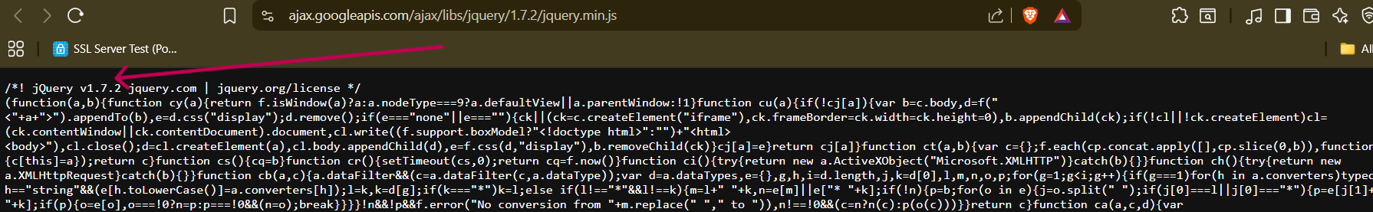
Recommendation:
Upgrade jQuery to the latest stable and secure version (3.x series)
Avoid version disclosure: Do not include the version number in the javaScript file name
Remove unnecessary comments or headers that reveal the version.
Implement audit and patch: Regularly audit and patch third-party libraries

Tool Used:- Browser
- Sensitive Backup / Certificate Files Accessible
Brief Description | Risk Rating | Impact on Application | Probability of Attack
The Application exposes sensitive files such as backup archives, configuration files, or SSL/TLS certificates through publicly accessible URLs. These files often contain highly confidential information like private keys, database credentials. Or source code. Such exposure can allow an attacker to download and misuse these files for further exploitation of the system. | High | High | High
Impact:
Private key exposure: Enables attackers to impersonate the application server and perform MITM attacks.
Database credential leakage: May lead to unauthorized access and data theft.
Source code/configuration disclosure: Helps attackers identify additional vulnerabilities.
Sensitive data compromise: Could lead to full application or infrastructure compromise.
Affected items:
http://164.100.117.150/elekhaHome.aspx
Proof of Concept:
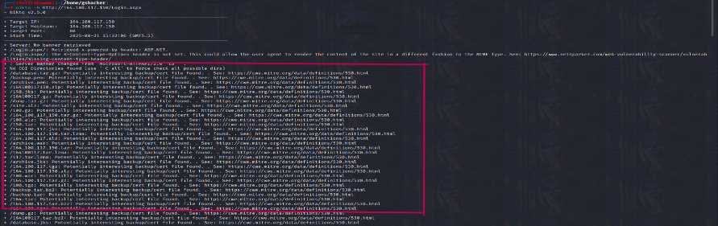

Recommendation:
Restrict Access: Ensure that sensitive files (.bak, .old, .zip, .tar, .pem, .crt, .key)
Apply proper file permission settins and web server restrictions.
Secure Configuration: Configure the web serverto deny access to backup and certificate directories

Tool Used:- Nikto
- Broken CAPTCHA Validation
Brief Description | Risk Rating | Impact on Application | Probability of Attack
The application implements a CAPTCHA field on the login page to prevent automated or brute-force attacks. However, testing revealed that CAPTCHA validation is not properly enforced on the server side. | High | High | Medium/High
Impact:
CAPTCHA Bypass: Attackers can directly remove the parameter and bypass the CAPTCHA mechanism.
Brute Force / Credential Stuffing: Without CAPTCHA enforcement, attackers can perform automated login attempts at scale.
Account Compromise: Weak accounts are at risk of being hijacked.
False Security: Users and administrators assume that CAPTCHA provides protection, but it is only cosmetic.

Affected items
http://164.100.117.150/Login.aspx
Proof of Concept:

No Captcha but same Error

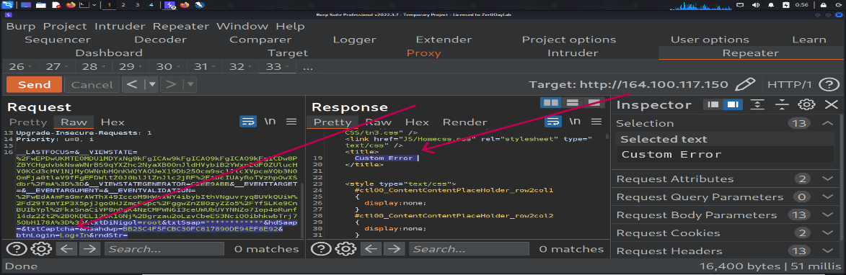

Wrong CAPTCHA but same error
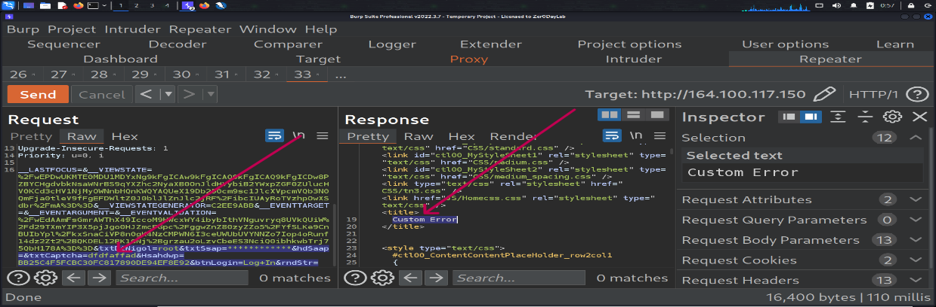

Write Captcha but same error

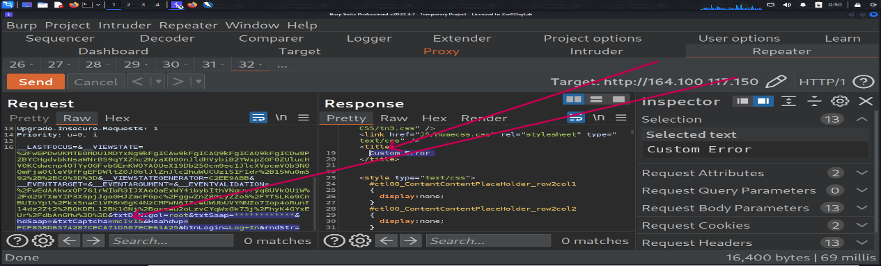

Page Load but Same Captcha

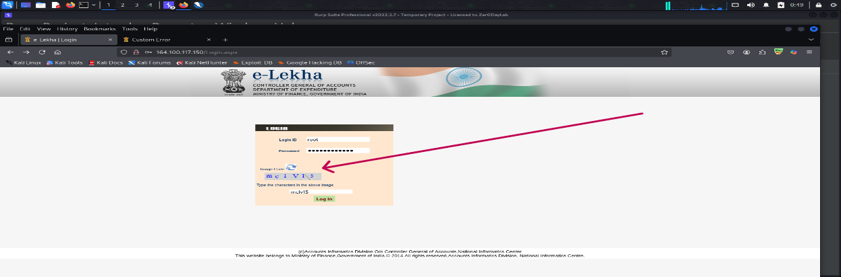

Recommendation:
Enforce CAPTCHA validation strictly on the server side.
Reject any request where the CAPTCHA value is missing, blank, or invalid.
Ensure CAPTCHA is: Dynamically generated for each session/page load.
Bound to the user session and expires after one attempt.
Avoid static or reusable CAPTCHA values.
Consider replacing weak CAPTCHA with robust solutions such as Google reCAPTCHA or Captcha to mitigate automated attacks.

Tool Used:- Burp suite
- Cross Domain Misconfiguration
Brief Description | Risk Rating | Impact on Application | Probability of Attack
The application is configured with and insecure Cross-Origin Resource Sharing policy. Specifically, the server allows requests from arbitrary or untrusted domains (e.g., Access-Control-Allow-Origin: * or reflecting user-supplied values). Such misconfiguration can allow malicious websites to interact with the application and access sensitive data through a victim’ s browser. | Medium | Medium | Medium/High
Impact:
Sensitive data exposure: An attacker-controlled domain could make authenticated requests on behalf of a victim and read sensitive responses.
Affected items
http://164.100.117.150/elekhaHome.aspx
Proof of Concept:
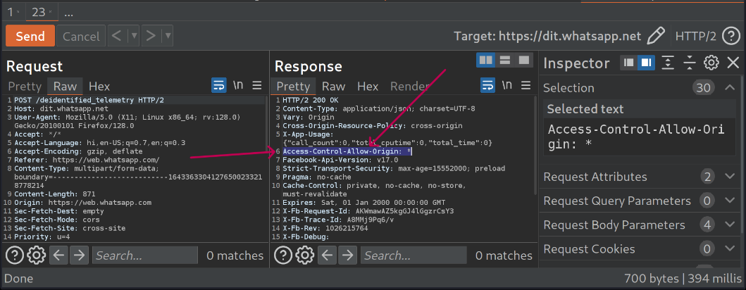

Recommendation:
Replace wildcard (*) or dynamic reflection with a strict whitelist of trusted domains.
Review business Requirements: Implement CORS only if cross-domain access is necessary.
Apply the principle of least privilege for allowed methods (GET, POST) and headers.
Tool Used:- Burp suite

- Content Security Policy header missing
Brief Description | Risk Rating | Impact on Application | Probability of Attack
Content Security Policy (CSP) is an added layer of security that helps to detect and mitigate certain types of attacks, including Cross Site Scripting (XSS) and data injection attacks. These attacks are used for everything from data theft to site defacement or distribution of malware. CSP provides a set of standard HTTP headers that allow website owners to declare approved sources of content that browsers should be allowed to load on that page — covered types are JavaScript, CSS, HTML frames, fonts, images and embeddable objects such as Java applets, ActiveX, audio and video files. | Medium | Medium | Medium
Impact:
Missing CSP makes the application vulnerable to XSS attacks.
Attackers can inject malicious JavaScript to steal cookies and sessions.
Unsafe external resources (scripts, images) may be loaded into the site.
Increases risk of clickjacking and data injection attacks.
Overall, user data and application integrity can be compromised.
Affected items
http://164.100.117.150/elekhaHome.aspx

Proof of Concept:
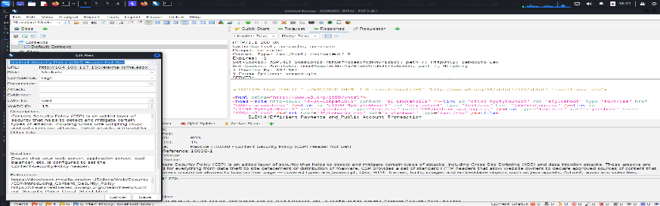

Recommendations:
Ensure that your web server, application server, load balancer, etc. is configured to set the Content-Security-Policy header.

Tool Used:- OWASP ZAP

Rate Limiting Missing on Login Endpoint
Brief Description | Risk Rating | Impact on Application | Probability of Attack
The login endpoint does not enforce rate limiting or account lockout mechanisms, allowing unlimited authentication attempts without restriction. | Medium | High | High
Impact: An attacker can perform automated brute force or credential stuffing attacks to guess valid force or credential stuffing attacks to guess valid usernames and passwords, potentially leading to unauthorized account access.
Affected items
http://164.100.117.150/elekhaHome.aspx

Proof of Concept:
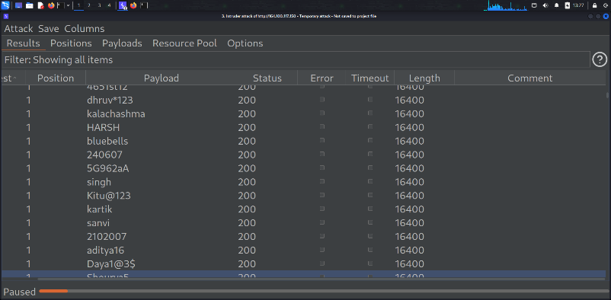
Recommendations:
Implement proper rate limiting, CAPTCHA, or account lockout after multiple failed attempts to prevent automated login abuse.

Tool Used: - Burpsuite

Cross-Domain JavaScript Source
Brief Description | Risk Rating | Impact on Application | Probability of Attack
The application includes JavaScript files from external (cross-domain) sources. If those external sources are compromised or controlled by an attacker, malicious JavaScript can be executed in the context of your website. | Medium | Medium | Medium
Impact:
Cross-Site Scripting (XSS)
Theft of sensitive data (cookies, localStorage, session tokens)
Session hijacking / account takeover
Malicious redirections or phishing
Supply chain attacks (like Magecart incidents)
Affected items

Proof of Concept:
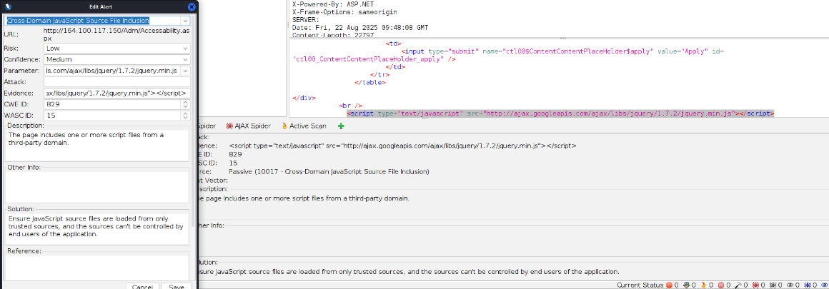
Recommendations:
- Avoid external JavaScript – Always host scripts locally on your own domain.
- If third-party scripts are required, use Subresource Integrity (SRI):
- Implement a Content Security Policy (CSP) to only allow trusted domains.
- Regularly review and update third-party dependencies.
- Prefer self-hosting third-party libraries instead of pulling them from external domains.

Tool Used:- OWASP ZAP

Vulnerable JavaScript Library Detected
Brief Description | Risk Rating | Impact on Application | Probability of Attack
The application is using an outdated or vulnerable JavaScript library (such as jQuery, Angular, Bootstrap, etc.) that contains known security flaws. Attackers can exploit these vulnerabilities to perform attacks like XSS, code injection, or bypassing security controls. | Medium | High | Medium
Impact:
- Attackers may exploit known CVEs in the library
- Can lead to Cross-Site Scripting (XSS), DoS attacks, or data theft.
- Compromised client-side security may allow attackers to take control of user sessions or manipulate the DOM.
Affected items

Proof of Concept:
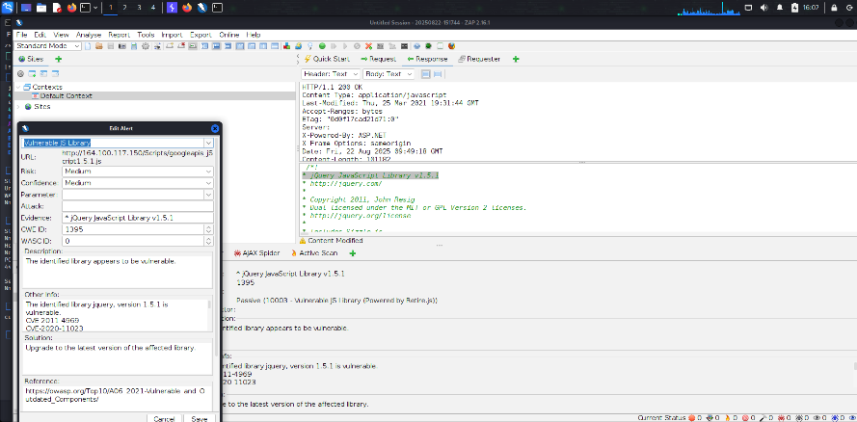
Recommendations:
Identify the vulnerable JavaScript libraries in use.
Upgrade to the latest stable and secure version of the library.
Remove unused or unnecessary libraries.
Regularly monitor security advisories (like NVD, GitHub Security Advisories).

Tool Used:- Owasp Zap

Missing Anti-CSRF Token in Forms
Brief Description | Risk Rating | Impact on Application | Probability of Attack
The application’s forms do not implement Anti-CSRF (Cross-Site Request Forgery) tokens. Without these tokens, attackers can trick authenticated users into unintentionally performing malicious actions (such as changing passwords, transferring funds, or modifying account details). | Medium | High | High

Impact:
Attackers can perform unauthorized actions on behalf of logged-in users.
Sensitive operations (like account updates, transactions) can be compromised.
Can lead to account takeover or data manipulation
Affected items
http://164.100.117.150/default.aspx

Proof of Concept:
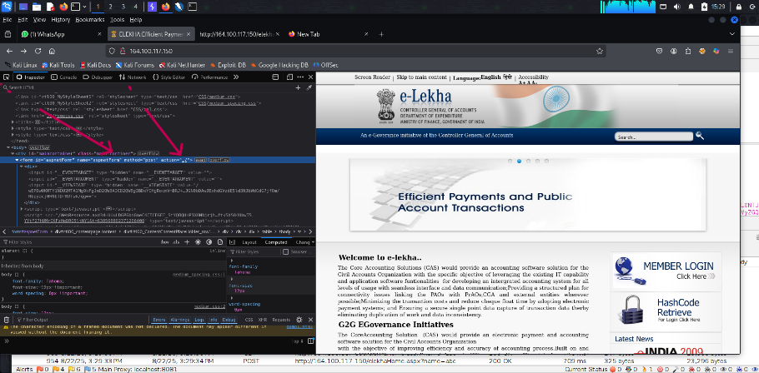
Recommendations:
- Implement unique, unpredictable CSRF tokens for all state-changing requests.
- Ensure that tokens are validated on the server side before processing the request.
- Use frameworks’ built-in CSRF protection mechanisms where available.
- Prefer SameSite cookies as an additional layer of defense.

Tool Used:- OWASP ZAP

Server Security Headers Missing
Brief Description | Risk Rating | Impact on Application | Probability of Attack
The application’s HTTP responses are missing important security headers (such as Content-Security-Policy, X-Content-Type-Options, Strict-Transport-Security, X-Frame-Options). These headers help protect against attacks like clickjacking, MIME sniffing, and code injection. | Medium | High | Medium

Impact:
- Increases risk of Cross-Site Scripting (XSS), Clickjacking, and man-in-the-middle (MITM) attacks.
- Sensitive data transmitted over the application may be exposed or manipulated.
- Reduces the browser’s built-in security protections, making exploitation easier.
Affected items:

Proof of Concept:
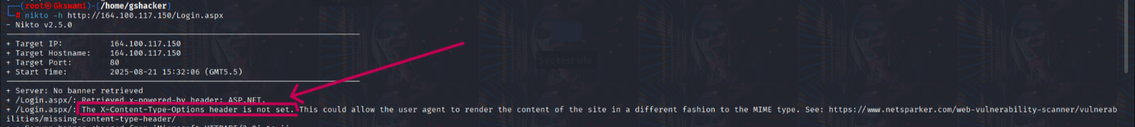

Recommendations:
Implement recommended security headers:
- Strict-Transport-Security → enforce HTTPS.
- X-Frame-Options → prevent clickjacking.
- X-Content-Type-Options → stop MIME sniffing.
- Content-Security-Policy → restrict scripts, styles, and resources.
• Regularly review and update header configurations.

Tool Used:- OWASP ZAP

X-Content-Type-Options Header Missing
Brief Description | Risk Rating | Impact on Application | Probability of Attack
The application’s HTTP responses do not include the X-Content-Type-Options: nosniff header. Without this header, browsers may perform MIME type sniffing and interpret files as a different content type, which can lead to execution of malicious code. | Low | Low | Medium

Impact:
Attackers can exploit MIME-sniffing behavior to execute malicious scripts.
May result in Cross-Site Scripting (XSS) or content injection.
Reduces the effectiveness of other security mechanisms.

Affected items:

Proof of Concept:

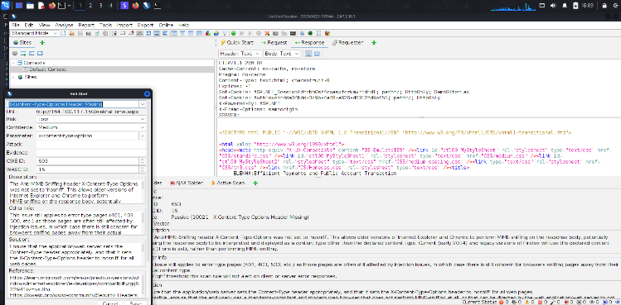

Recommendations:
Add the security header in server response:
X-Content-Type-Options: nosniff
Configure it at the web server or application framework level.
Regularly audit security headers for compliance.

Tool Used:- OWASP ZAP

Information Disclosure via X-Powered-By (ASP.NET)
Brief Description | Risk Rating | Impact on Application | Probability of Attack
The application discloses its underlying technology stack through the X-Powered-By HTTP response header (e.g., ASP.NET). Revealing framework and version details gives attackers valuable information that can be used to identify known vulnerabilities or tailor attacks. | Low | Medium | Medium
Impact:
Helps attackers in fingerprinting the application’s backend.
Increases the risk of targeted exploitation against known vulnerabilities in ASP.NET.
Can lead to further reconnaissance and potential compromise.

Affected items

Proof of Concept:

Recommendations:
Disable or remove the X-Powered-By response header from server configurations.
In IIS/ASP.NET, disable it via web.config or URL rewrite rules.
Implement security-through-minimization by avoiding unnecessary header disclosures.

Tool Used:- Nikto

User-Agent Fuzzer Info
Brief Description | Risk Rating | Impact on Application | Probability of Attack
During fuzz testing with multiple or malformed User-Agent strings, the server/application responded differently (e.g., error messages, crashes, or altered behavior). This indicates that the application does not properly validate or sanitize the User-Agent header, which may lead to unexpected behavior or potential exploitation. | Low | Low | Low
Impact:
Reveals inconsistencies in how the application processes HTTP headers.
May allow attackers to perform denial of service (DoS), logic bypass, or even exploit hidden bugs.
Can expose information about server-side filtering, logging, or monitoring mechanisms.

Affected items

Proof of Concept:
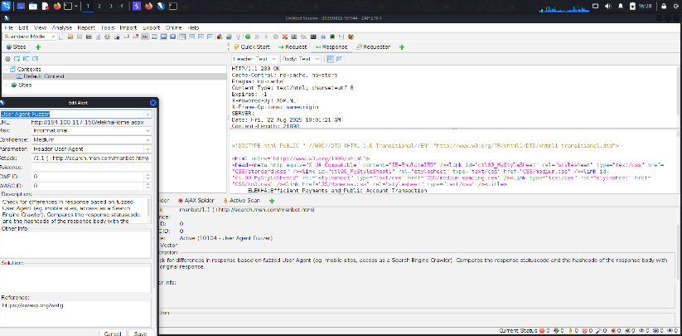
Recommendations:
Implement strict validation and sanitization of the User-Agent header.
Do not rely on the User-Agent value for authentication, authorization, or critical logic.
Ensure the application handles unexpected or malformed inputs gracefully without revealing errors.
Regularly test with fuzzing tools to identify and patch such weaknesses.
Tool Used:- OWASP ZAP

Timestamp Disclosure in Response Headers
Brief Description | Risk Rating | Impact on Application | Probability of Attack
The application’s HTTP response headers include a timestamp value (e.g., Date, Last-Modified, or custom headers). Disclosing such information may assist attackers in determining the server’s internal clock, uptime, or file modification times, which can be useful for reconnaissance and targeted attacks. | Low | Low | Low
Impact:
- Provides attackers with details about server time, uptime, and file modification dates.
- Can help in session prediction, replay attacks, or correlation of events.
- Increases the risk of targeted exploitation by aiding in reconnaissance.

Affected items

Proof of Concept:
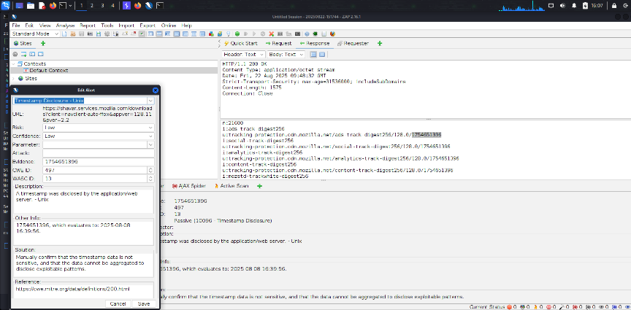

Recommendations:
Remove unnecessary timestamp-related headers (e.g., Last-Modified, X-Generated-Time) unless explicitly required.
If timestamps are needed, ensure they do not leak sensitive information (e.g., internal system time or build time).
Use generic values or caching mechanisms instead of exposing detailed modification times.

Tool Used:- OWASP ZAP

Session Management Response identified
Brief Description | Risk Rating | Impact on Application | Probability of Attack
The application’s HTTP responses reveal session management details (such as Set-Cookie, ASP.NET_SessionId, JSESSIONID, or other session identifiers). If session tokens are not properly secured (e.g., missing HttpOnly, Secure, SameSite flags), they may be intercepted or manipulated, leading to session hijacking. | Low | Low | Low
Impact:
Attackers may steal or manipulate session tokens to gain unauthorized access.
Missing cookie security flags may allow XSS or MITM attacks to compromise sessions.
Can lead to account takeover or persistent user impersonation.

Affected items

Proof of Concept:
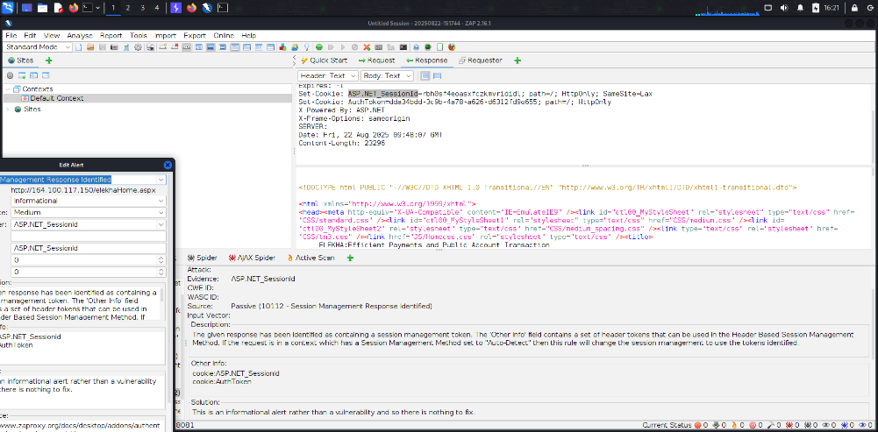

Recommendations:
Ensure session cookies have the following security attributes:
HttpOnly → prevents client-side scripts from accessing the cookie.
Secure → ensures cookie is transmitted only over HTTPS.
SameSite → mitigates CSRF attacks.
Implement session timeouts and regenerate session IDs after login/logout.
Avoid exposing session IDs in URLs or logs.
Tool Used:- OWASP ZAP

Timestamp Disclosure
Brief Description | Risk Rating | Impact on Application | Probability of Attack
The application reveals timestamp information in responses or page content, which can disclose system or application update details. | Low | Low | Low
Impact:
Attackers can use timestamp data to infer system uptime, software version age, or patch
timelines, aiding in targeted attacks.

Affected items
https://tracking-protection.cdn.mozilla.net/google-trackwhite-digest256/128.0/1754651396

Proof of Concept:
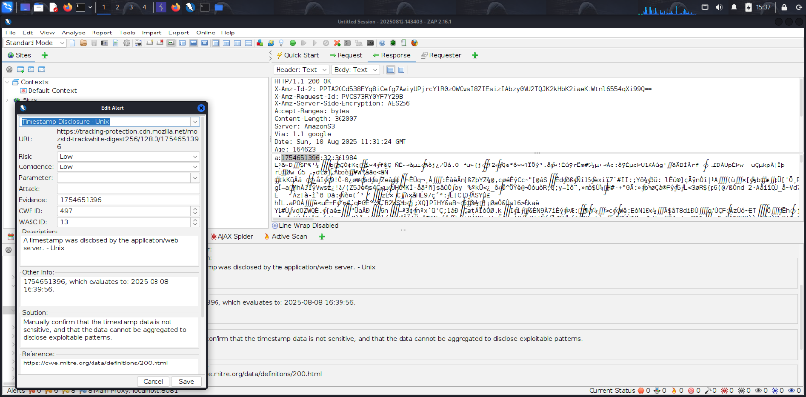

Recommendations:
Remove or obfuscate timestamp information from client-facing content unless required for functionality.

Tool Used:- OWASP ZAP

X-Aspnet version response Header
Brief Description | Risk Rating | Impact on Application | Probability of Attack
The application discloses the ASP.NET version in the X-AspNet-Version HTTP response header. | Low | Low | Low
Impact:
Revealing the framework version can help attackers identify specific vulnerabilities and target
known exploits.

Affected items
http://164.100.150.68

Proof of Concept:
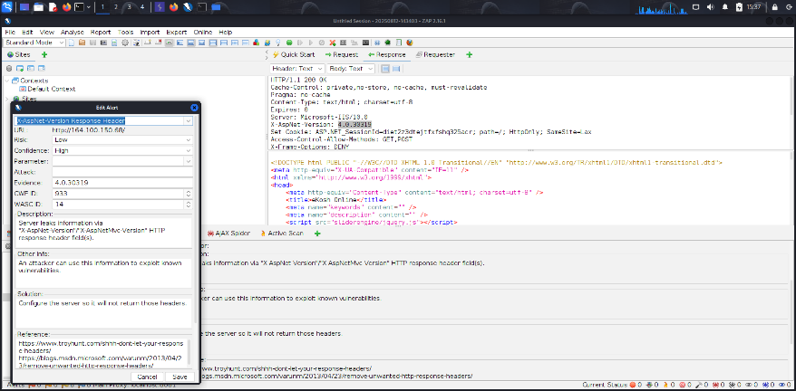

Recommendations:
Configure the server to remove or suppress the X-AspNet-Version header from HTTP responses.
Tool Used:- OWASP ZAP

General Guidelines
Validate Input and Output
The input that the server receives from the user can lead to malicious code entering the server. Similarly, the output shown to the user can transmit malicious code to the client system. All user input and output should be checked to ensure it is both appropriate and expected. Input validation should be done on the client-side as well as on the server-side.
There are three main models to consider about when designing a data validation strategy.
Accept Only Known Valid Data
A character set may be defined for each field where input from the user is accepted. E.g. “A-Z, a-z, @,., 0-9, _” is a character set for a field that accepts user email.
Reject Known Bad Data
A character set of bad data may be defined for the site that has to be rejected. E.g. “CREATE, DROP, OR”
Sanitize Known Bad Data
A character set of bad data is defined and any input field that has such a character is modified. E.g. “If there is a single quote (‘) in the data, it is replaced with two single quotes.”
All methods must check:
- Data Type
- Syntax
- Length
It is recommended to use the strategy of “Accept only known data”. Further all the allowed input/output data must be sanitized on the server side by replacing scripts tags, sent as part of user input/output, with appropriate representations.
For example
- “<” by &lt;
- “>” by &gt;
- “(“ by &#40

This would avoid scripts from being executed on the client side.
Client-side input must also be checked for URL encoded data. URL encoding sometimes referred to as percent encoding, is the accepted method of representing characters within a URI that may need special syntax handling to be correctly interpreted. This is achieved by encoding the character to be interpreted with a sequence of three characters. This triplet sequence consists of the percentage character “%” followed by the two hexadecimal digits representing the octet code of the original character. For example, the US-ASCII character set represents a space with octet code 32, or hexadecimal 20. Thus, its URL-encoded representation is %20.
Other common characters that can be used for malicious purposes and their URL encoded representations are: -
# | Character | URL encoded
 | ‘ | %27
 | “ | %22
 | ; | %3b
 | < | %3c
 | = | %3d
 | > | %3e
 | ) | %29
 | ( | %28
 | space | %20

All input validation checks should be completed after the data has been decoded and validated as acceptable content (e.g. maximum and minimum lengths, correct data type, does not contain any encoded data, textual data only contains the characters a-z and A-Z etc.)
A one-time check on the database is to be made for invalid malicious data. This would enable removal of input that has not been validated in earlier sessions. As otherwise the invalid data may cause script execution on the user’s browser.

Session Management / Strong session tracking
Session Tokens on Logout
In shared computing environments, session tokens take on a new risk. If the session tokens are not invalidated after logout, they can be reused to gain access to the application. It is imperative for the application to remove the cookies from both the server and the client side after the user has logged out. The user session maintained on the server side must also be invalidated immediately after logout.
Session Time-out
All the user Session tokens must be timed-out after a certain interval of user inactivity. The Session tokens that do not expire on the HTTP server can allow an attacker unlimited time to guess or brute force a valid authenticated session token. If a user's cookie file is captured or brute-forced, then an attacker can use these static-session tokens to gain access to that user's web accounts. Additionally, session tokens can be potentially logged and cached in proxy servers that, if broken into by an attacker, may contain similar sorts of information in logs that can be exploited if the particular session has not been expired on the HTTP server.
Session Token Transmission
If a session token is captured in transit through network interception, a web application account is then trivially prone to a replay or hijacking attack. Typical web encryption technologies include Secure Sockets Layer (SSLv2/v3) and Transport Layer Security (TLS v1) protocols in order to safeguard the state mechanism token.
Some more key points to remember:
Session ID’s that are used should have the following properties:
- Randomness.
  - Session Ids must be randomly generated.
  - Session Ids must be unpredictable.
  - Make use of non-linear algorithms to generate session ID’s
- Session ID Size
  - The size of a session ID should be large enough to ensure that it is not vulnerable to a brute force attack.
  - The character set used should be complex. i.e. Make use of special characters.
  - A length of 50 random characters is advised.
Salted Hashing
What is salted hashing?
The process starts with 2 elements of data:
1.) A clear text string (this could represent a password for instance).
2.) The salt, a random seed of data. This is the value used to augment a hash in order to ensure that 2 hashes of identical data yield different output.
In pseudo code we generate a salted hash as follows:
1.) Get the source string and salt as separate binary objects
2.) Concatenate the 2 binary values
3.) SHA hash the concatenation into Salted Password Hash
4.) Base64 Encode (concat (Salted Password Hash, Salt))
Credentials should be encrypted using salted hashes, so that even if the hashes are sniffed the possibility of replay attack does not exist.
References: http://www.owasp.org/images/3/33/Salted_Hashes_Demystified.doc
Cache Control Directives
Pages that contain sensitive information should not be stored in the local cache of the browser. To enforce this, HTTP directives need to be specified in the response. These HTTP directives need to be used to prevent enlisting of links on the browser history. The following HTTP directives can be sent by the server along with the response to the client. This would direct the browser to send a new request to the server each time it is generated.
Expires: <a previous date>, for e.g. Expires: Thu, 10 Jan 2020 19:20:00 GMT

Cache-Control: private
- Cache-Control: no-cache
- Cache-Control: no-store
- Cache-Control: must-revalidate
- Pragma: no-cache

The directive “Cache-Control: must-revalidate” directs the browser to fetch the pages from the server rather than picking it up from the local “Temporary Internet Folders”. It also directs the browser to remove the file from the temporary folders.

